


 Tilery Times Issue no 233

54 days until 2016 Lantern Parade
www.sbcschools.org.uk/tilery
w/e 11.12.15
HEADTEACHER’S NEWS
Dear parent, carer, pupil, friend of our school,
It has been really good to see so many parents, grand-parents and carers at school for our performances of Angel Express and Snowman at Sunset. Our pupils really did everyone proud and have got Christmas at Tilery off to a brilliant start.
The Christmas parties will begin today with Y3 and Miss Henderson’s class, next Monday it will be Y1 and Y2, Tuesday Miss Gent’s and Y5, Thursday will be Early Explorers and Y6.
Next Monday morning children from FS2 to Y6 will be watching the Fame Academy Spotlight Academy perform “Beauty and the Beast” in our school hall.
Our 4 football teams (A team, Tigers, Lions and Cheetahs) took part in the Daisy Chain Christmas 5 a side football competition at Seaton Football Dome on Thursday 10th December. Our teams represented the school very well and played their games in an excellent spirit. Well done to the A team who came second in the competition and the players of the day Brandon Bowes – Leonard, Skye Canham, Shane Meir and Shaun Cubitt.
Parents, carers and friends of our school are very welcome to come and join us at Stockton Parish Church for the school Christingle service next Thursday at 9.45am. This is one of the school’s flagship events and it is always very special to see our Y6s process around the church with their Christingle candles.

Have a good weekend and I hope your preparations for Christmas are going well,

Best wishes
J.P.Repton

ATTENDANCE - 30/11/15 –04/12/15

Class | % | Position
Mrs Pickering | 99.3% | 1st  1st
Miss Henderson | 98.2% | 2nd
Miss Gent | 97.4% | 3rd
Mrs Fearn | 97.2% | 4th
Miss Prince | 97% | 5th
Mrs Fender | 96.5% | 6th
Miss Shildrick | 95.8% | 7th
Mrs Hodgson | 95.6% | 8th
Mrs Robson | 94.7% | 9th
Mrs Roberts | 93.7% | 10th
Miss Hunt | 92.6% | 11th

Our named Local Authority Attendance Officer is Karen Weschenfelder who will be monitoring attendance and punctuality closely. Karen will be supporting school in raising our attendance and addressing absence.
Please remember to inform school when your child is absent as all unexplained absence will be recorded as unauthorised.
Pupil & Family Support Workers Gill and Christine are available in school to discuss any issues with Parents/carers.

National Christmas Jumper Day & Reward Day

There is lots happening in school next Friday!!It’s National Christmas Jumper Day and also our Reward Day Disco, so children can come to school dressed in their Christmassy clothes or jumpers (This terms £5 Annual Contribution must be paid before the Disco - please pay at the School Office if you haven’t done so already) It will also be Toy Day and children are welcome to bring a toy to school (no electronic games or consoles please).

JUST A LITTLE REMINDER
Throughout the year the children will take part in many exciting activities and educational activities to enhance their learning. Funds raised at school fairs, raffles and other events are put toward these; however, the annual parental contribution is essential to make such a range of activities possible for all of the children. The Autumn Term Annual Contribution of £5.00 is now due and should be paid into school by Monday 14th December. As a thank you to all families that have paid their contribution children will be taking part in the school disco at the end of term, and there will also be a draw with the chance to win a £10 Asda voucher and a selection box.

CHRISTMAS DINNER – WEDNESDAY 16TH DECEMBER
We are all looking forward to Christmas dinner day at school. Pupils will be able to choose from Turkey with all the trimmings, Quiche and a vegetarian loaf (a change to the advertised menu). There will be smiley face ice cream, biscuits and Christmas pudding with sauce. Children will be asked to choose their main course on Monday next week (14th December). If your child usually brings a packed lunch and would like a dinner on this day, just pop into the office and let us know. There is a charge of £2.05 per child.

FAMILY BREAKFAST FRIDAY 18TH DECEMBER
You are all welcome to our family breakfast next Friday (the last day of term). Maxine and the team will be serving eggs, beans, cereal, bagels, toast, tea, coffee and orange juice.

No need to book and the cost is just 50p per person. Open from 7.30 until 9.00am. We are looking forward to seeing you there!

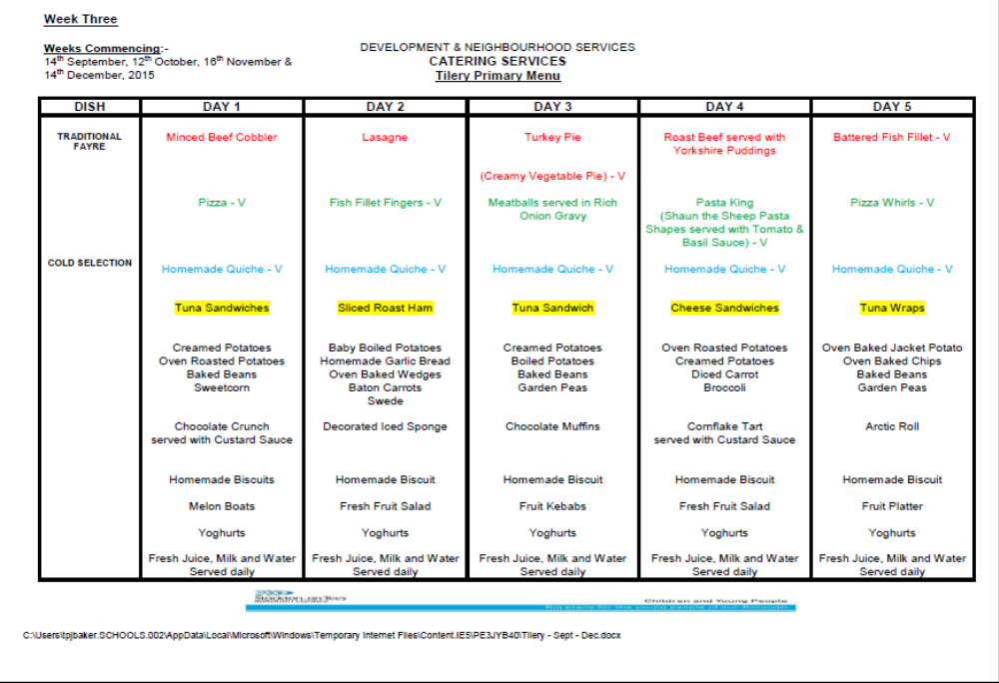

Tilery Primary School
Christingle Service


At Stockton Parish Church on
Thursday 17th December
at 9:45 am.

 Please join us for a
truly festive celebration.

