 ***Tilery Times Issue no 313***

**www.sbcschools.org.uk/tilery**



**5 days until 2018 Lantern Parade**

***w/e 25.01.18***

**HEADTEACHER’S NEWS**

Dear Parent, Carer, Pupil, Friend of our school,

So our Lantern making is in full swing now with some lovely house lanterns (all with at least one star incorporated of course) and imaginatively shaped ones, being worked on by groups of children and many others by family groups. A special mention for our Y6 pupils who have worked with great determination and teamwork on their stretcher based Lanterns. I am sure their castles, boats and their special royal wedding limousine amongst others will look amazing in the parade next Thursday.

We are hoping to see lots of family groups coming in to the Lantern making workshop tomorrow (Saturday) from 10am to 4pm. This is an opportunity for families to work together on finishing their Lanterns or even to start a simple Lantern. We are also welcoming Y6 pupils to come to school during these times to work on their own lanterns, as well as former pupils. Lunch will be prepared by four Y6 children and staff and will include a chilli and rice ,fresh homemade pizzas, curry and rice ,baked potatoes with a range of toppings, with bread and butter pudding and custard, cheese cake and fruit kebabs for pudding.

Workshops will continue each day next week up until the parade. Monday will be a late 6pm finish with Tuesday and Wednesday being a 5pm finish. Parents and carers can come into school during the day at any time to work with their child(ren) to complete their lantern.

We will be sending out full information about the parade event on Monday but please keep next Thursday evening clear in your diary!

Monday afternoon saw the first ever Lantern Trophy football competition for our Y1/2 pupils. It was superb to see our youngest footballers playing with such energy and pure enjoyment. It looks like we have some really talented players that will go on to represent our school for many years into the future. Well done to the winning captain Alex Cotterill- Stephens and his team for winning the competition. On Tuesday the first ever Y3/4 Lantern Trophy Competition took place. This was also a great competition played with great determination and bravery. Well done to Sophie Vickers and her team for winning the competition after a very close golden goal final. Players of the tournament were for Y1/2 Emily Armstrong and for Y3/4 Leyton Eales. An excellent achievement for both.

Happy lantern making and hope to see you on Saturday.

Best wishes

J.P.Repton

Best wishes

J.P.Repton

**LANTERN PARADE LUNCH**

SATURDAY 27TH JANUARY

Beef Chilli

Tomato and Cheese Pizza

Vegetable Curry and Rice

Jacket Potatoes

Cheese

Beans

Tuna/Mayonnaise

Fruit Kebabs

Bread and Butter Pudding

Cheesecake

Custard

**ATTENDANCE – 15/01/18 – 19/01/18**

|  |  |  |
| --- | --- | --- |
| **Class** | **%** | **Position** |
| Mrs Fearn | 98 | 1st  1st |
| Miss Gent | 97.4 | 2nd |
| Mrs Pickering | 96.4 | 3rd |
| Mrs Robinson | 96.1 | 4th |
| Miss Hunt | 94.3 | 5th |
| Mrs Rodgers | 94.1 | 6th |
| Mrs Fender | 92.1 | 7th |
| Mrs Beamson | 92  90.5 | 8th |
| Miss Shildrick | 90.5 | 9th |





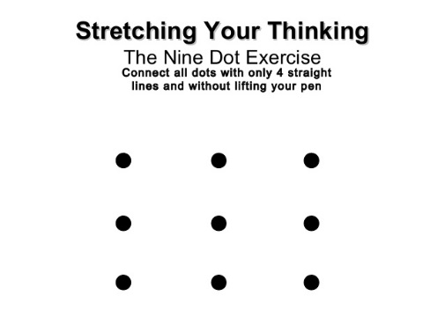

**The answer to last week’s Maths Problem**

**STAFF CAR PARK**

Can we please request that parent/carers **DO** **NOT** enter the staff car park in vehicles.

Children can be dropped off at the footpath and walk safely into school. Taxis and staff are finding it difficult to enter the car park due to congestion and cars leaving.

Thank you for your

co-operation.

**GOVERNORS NEWS**

At the Full Governing Body Meeting on Thursday 18th January, Governors were delighted to hear that plans for Lantern Parade 2018 are now well underway.

We hope that you all enjoy the workshops and look forward to seeing the magnificent spectacle the finished lanterns create on 1st February.

Hopefully the weather will be kind!

Liz Miller, Chair of Governors

**STEP FORWARD TEES VALLEY**

Step Forward Tees Valley is a project working throughout the whole of the Tees Valley helping people getting closer to or into employment. To do this we work with agencies to overcome barriers that prevent people from working, this can be from mental ill health including undiagnosed anxiety, depression or low moods.

Financial struggles? We provide support with benefits and other debt problems. We also support people through training and work placements.  Age range is 29 years+, however we can work with under 29s in exceptional circumstances.

Please contact our office on 01642 607028 if you are interested, or ask Christine Pratt or Mr Cliff for more details.

Additionally, if you see Laura Williams (one of our representatives) at the Lantern parade / workshop please feel free to say hello to her.

**By Mr Cliff**

**WEEK 1**

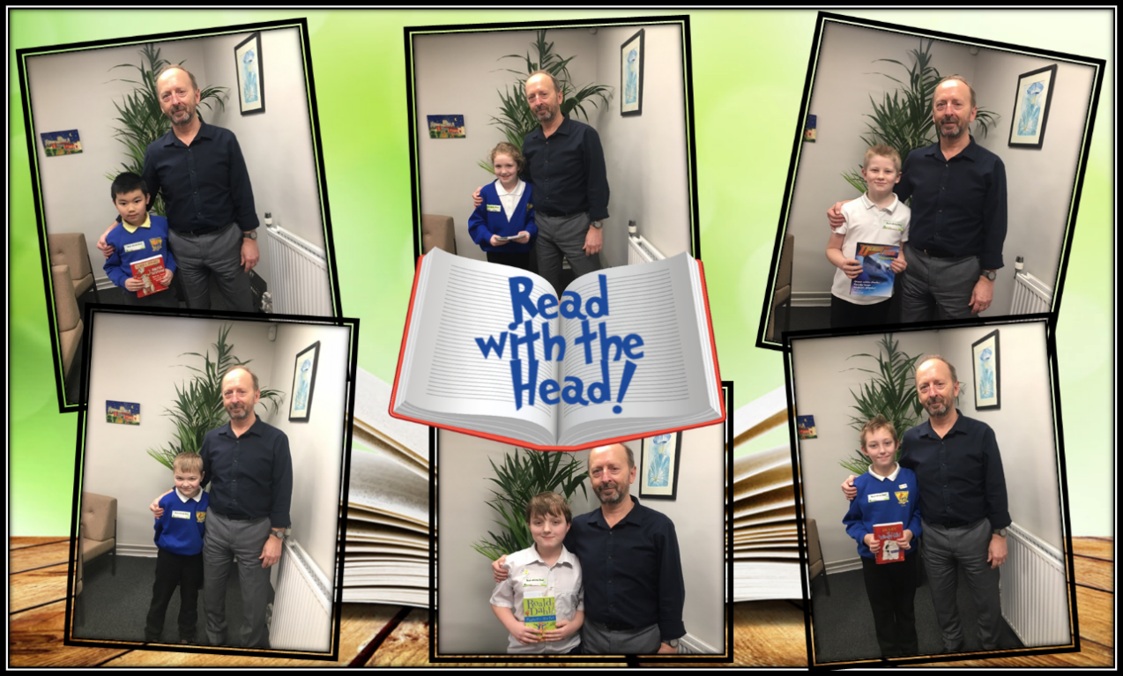

**WEEK 2**

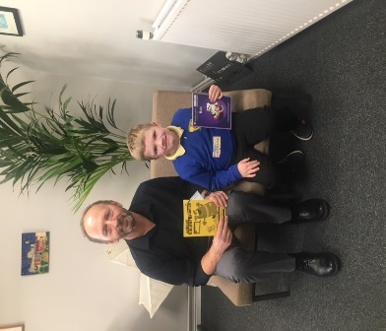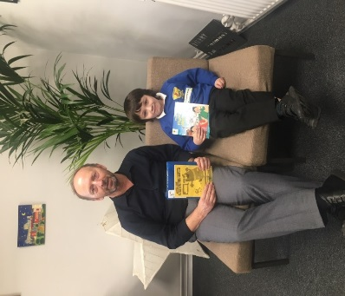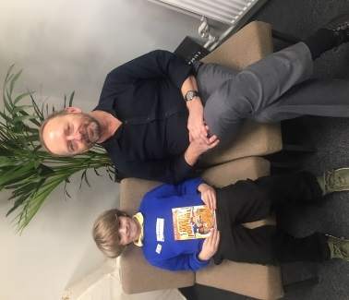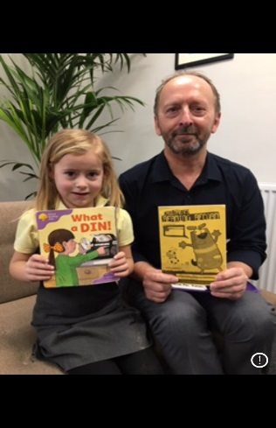

**Lantern Trophy 2018**

**Year 1&2 Team Captain Alex Cotterill-Stephens Year 3&4 Team Captain Sophie Vickers**

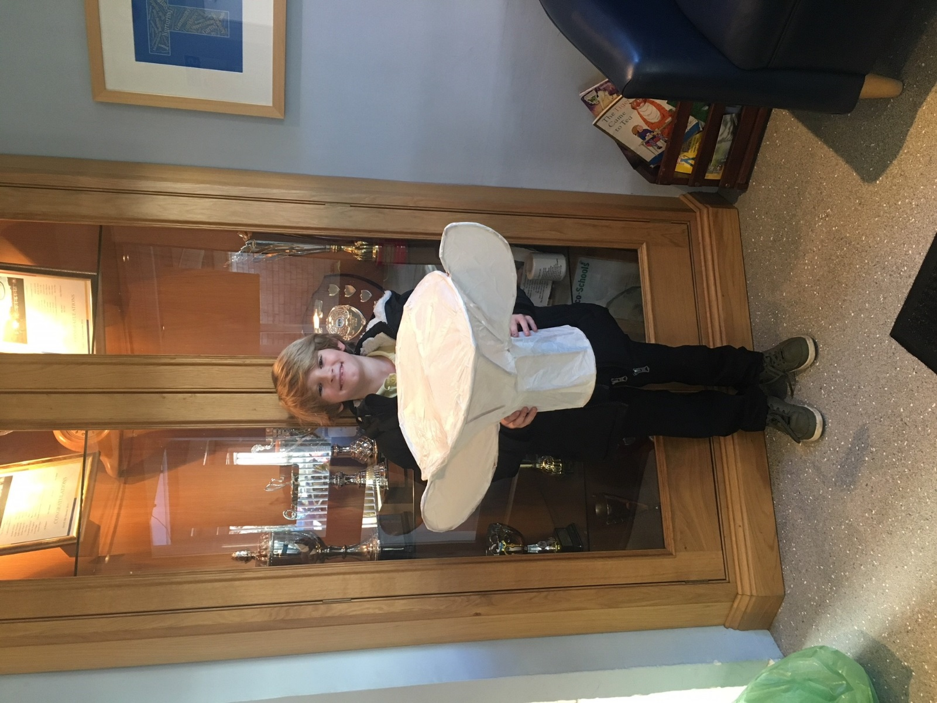 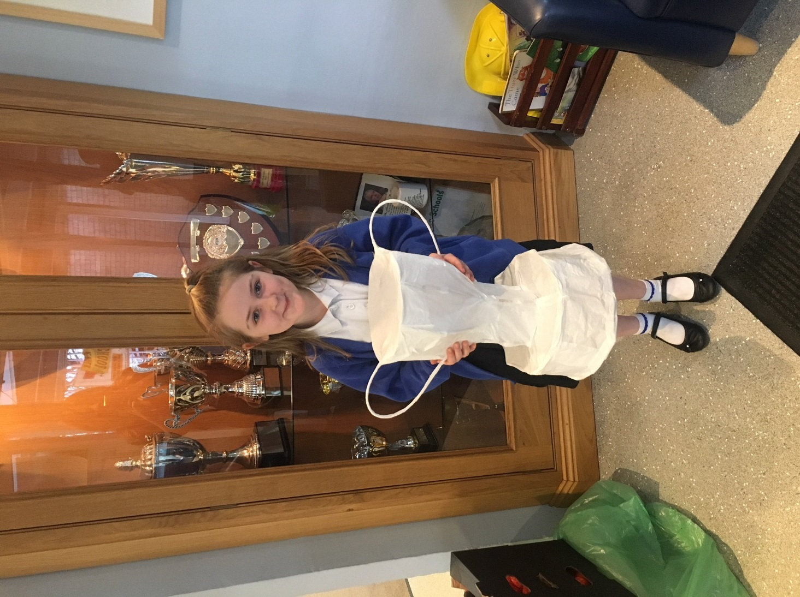

**Berry Banana Cheesecake**

**Method**

1. Put the digestive biscuits in a food bag, and using your fists press into small pieces. Pour a layer of the crumbled biscuits into the bottom of each glass.
2. Slice half the banana into a jug, add the honey, vanilla essence, yogurt and fromage frais. Use the hand-held blender to mix the ingredients until smooth. Pour the mixture over the crushed biscuits, sharing evenly between the glasses.
3. Leave in the fridge for at least half an hour to chill. Just before serving, slice the strawberries and the rest of the banana and place on top of the cheesecakes, sharing the fruit evenly between the glasses. Dust lightly with cocoa powder.

**Equipment:** Chopping board, knife, jug, blender,

measuring spoons, glasses to serve.

**Allergens**\***:** Gluten | Milk

**Ingredients (serves 2):**

1. 2 digestive biscuits
2. 2 tbsp thick plain low fat yogurt
3. 2 tbsp fromage frais
4. 1 banana
5. 6 strawberries
6. 1 tsp honey
7. 1/2 tsp vanilla essence
8. Dusting cocoa powder