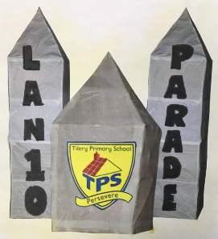

**www.sbcschools.org.uk/tilery**

***Lantern Festival 2019***

***Issue no 350***

**13 days until the Lantern Festival  *w/e 25.01.19***

**Lantern Festival News**

As our annual Lantern Festival is fast approaching, we would like to take this opportunity to draw your attention to some key dates for your diary. This year, the event will be held on the evening of Thursday 7th February, meeting at school at 5.30pm for a 6pm start. Should we need to, we have a reserve date of Wednesday 13th February.

We have an exciting opportunity for parents/carers who are new to Lantern making to come along and join us for one of our 1-hour workshops on Friday 25th January. Please see times below. We hope you can make this and we look forward to sharing our annual tradition with you.

Frame-making workshops

* Saturday 26th and Sunday 27th January 10am – 3pm

Covering and finishing off workshops

* Saturday 2nd February 10am – 4pm

Please Note

During the lantern festival activities period, there will be no after school clubs, however Tilery After School club will still be running as normal. There will also be Year 6 SATS booster sessions still available for all Year 6 pupils to attend. Dates and Times to follow.

**HEADTEACHER’S NEWS**

Dear Parent, carer, pupil, friend of our school,

Our Lantern Festival is off to a good start. Our pupils from Early Explorers have been having fun making their Little Lights with their parents. They are already looking really good and will look amazing when they are lit up on the night of the parade.

The beginner’s workshops are taking place today and then tomorrow we go up a couple of gears for the Saturday and Sunday (10am-3pm each day) workshops. This will be for families to come in and start making their Lanterns. This is open to every family in the school. A free hot lunch, cooked by Y6 children, former pupils and staff will be available for all on both the days. Mary and Gilly, our two artists, will be there for both the days. It will be a lovely community weekend for all involved, so we hope to see lots of people there preparing for what will be a very special 10th anniversary parade.

Enjoy your Lantern making

Best wishes

J.P.Repton

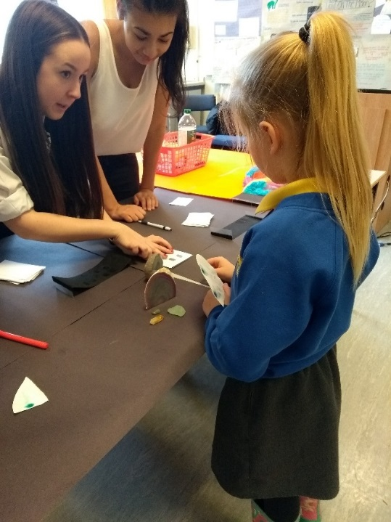

**ATTENDANCE – 11.01.2019 – 18.01.2019**

|  |  |  |
| --- | --- | --- |
| **Class Teacher** | **%** | **Position** |
| Mr Cliff | 99.6 | 1st |
| Mrs Pickering | 98.7 | 2nd |
| Mrs Fearn | 95.9 | 3rd |
| Mrs Chapman | 95.6 | 4th |
| Mrs Rodgers | 94.4 | 5th |
| Mrs Fender | 94.1 | 6th |
| Miss Gent | 94 | 7th |
| Mrs Beamson | 92.5 | 8th |
| Mrs Roberts | 32 | 9th |
| Miss Hunt | 85.7 | 10th |

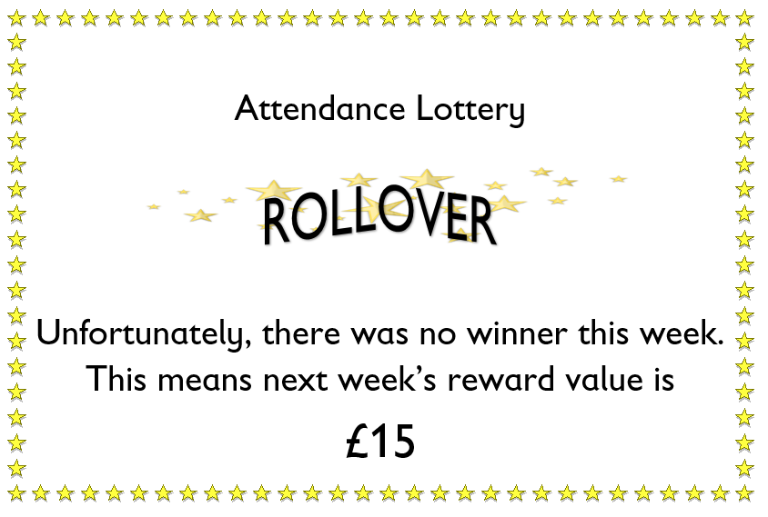





Lost Property

A child’s bike helmet has been found in the bushes on the premises; please contact reception if this belongs to you.

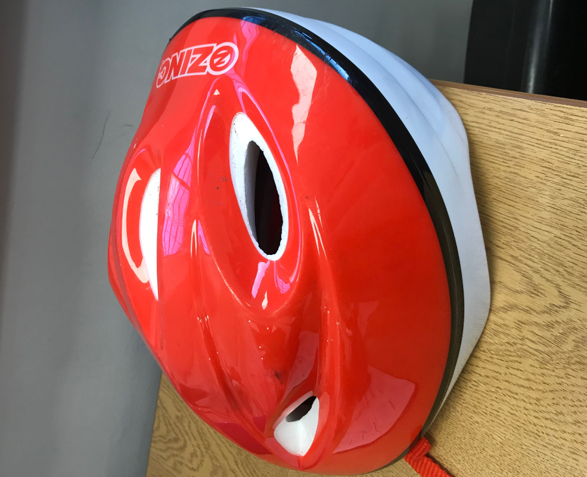

Brainteaser





Please check back next week for the answer and winner

Lantern Parade

Our stock is running very low for 1.5 litre and 2 litre clear bottles for our FS2 and KS1 pupils to make their ‘little light’ lanterns.

Please can you send any bottles you have into the office by no later than Thursday 31st January so we have enough stock for each pupil to make a lantern.

Vegetable Curry Recipe

During our Lantern Festival workshops, we will be serving up some delicious

main and desert foods such as our Tilery Pasta, Chicken Curry, Vegetable Curry,

chocolate cake and Bread and Butter Pudding, as well as a range of fresh salads

and fruits.

Each week, we will be providing you with the recipe from one of these meals for

you to make at home with your family. This week we have given you the recipe for a vegetable curry.

Ingredients

* 1 large potato, diced
* 1 small butternut squash, peeled, deseeded and diced
* 1 aubergine, diced
* 6 tbsp tikka masala paste
* 3 tbsp vegetable oil
* 2 onions, sliced
* 680g-700g jar tomato passata
* 400g can coconut milk
* 2 red peppers, sliced
* 2 courgettes, diced
* few coriander sprigs, to serve
* rice or naan bread, to serve

Method

1. Heat oven to 200C/180C fan/gas 6. Toss the potato, squash and aubergine with 2 tbsp curry paste and 2 tbsp oil in a large roasting tin. Season, then roast for 30 mins.
2. Meanwhile, make the sauce. Fry the onions in the remaining oil in a large pan until softened and golden – add a splash of water if they start to dry out. Stir in the remaining curry paste, cook for 3 mins, then add the passata, coconut milk and 100ml water. Simmer for a few mins.
3. When the vegetables are roasted, tip them into the sauce with the peppers and courgettes. Simmer for 10-15 mins until tender. Scatter with coriander and serve

Please check next week for another exciting and delicious recipe for you to try at home with your family.

